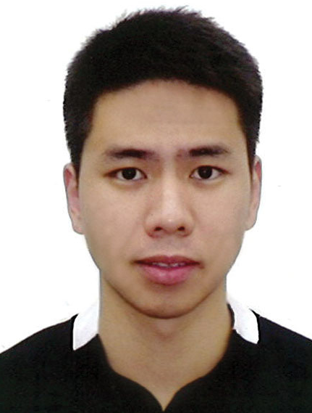

I am a recent graduate in Commerce from the University of Western Australia (UWA) seeking to pursue a career that will build up my analytical, communications and leadership skills. At the same time, contributing to the growth of any company I join in its strategic vision.

**Lee Wen Feng Justin**

Mobile: +65 91504660

Email: [justincredulously@gmail.com](mailto:justincredulously@gmail.com)

**Education**

**University of Western Australia** **2014 – 2017**

* Bachelor of Commerce (Major in Economics, Minor in Finance)

**Temasek Junior College (Integrated Programme) 2007 – 2011**

* GCE A ‘Levels
* Higher Chinese Education

**Victoria School 2005 – 2006**

* Higher Chinese Education

**Awards and Scholarship**

* School Academic Award **2007**
* School Merit Award (CCA leadership) **2011**

**Work Experience**

**3rd Sergeant, Combat Engineers 38 SCE, Singapore Armed Forces**

**Dec 2011 – December 2013**

* Led efforts to maintain highly classified equipment for the unit’s annual Logistic Audit Branch (LAB) to obtain the Battalion’s outstanding distinction grade for inspections
* Part of a 6-man crew in various Army Exercises, NDP 2013 and Army Open house 2013

**Work Experience**

**Grab Marketing Ambassador (GrabCar Mobile Platform)**

**Sept 2017 – present**

* Developed marketing efforts to further spread the awareness of the Grab Car Service
* Direct selling to other platform drivers to engage and thus convert them to use Grab Car
* Managed to top his batch of Field agents by nabbing the most sales

**EXTERNAL ACTIVITIES**

**Vice-Captain of Soccer, Temasek Junior College Jun 2010 – Jun 2011**

* Led and represented the College in the National Inter-School Soccer A Division.

**Student Council (IP) Feb 2008 – April 2008**

* Led and organized school activities for the new batch of Junior College year 1 students who were enrolled into Temasek Junior College for the first 3 months to help them further integrate into the school’s curriculum.

**Orientation Group Leader, Unihall (UWA) July 2015 – July 2015**

* Organized and led activities for the Freshmen Orientation Programme in 2015

**Member of Track and Field, Temasek Junior College Jan 2007- August 2009**

* Participated in the long jump and 100-meters sprint during the National Inter-School Track and Field for both the A and B division.

**STRENGTHS INCLUDE:**

* Self-Starter, fast-learner and capable to work independently
* Effective communicator with strong stakeholder buy-in and management
* Work well independently as well as collaboratively in a team environment.

**ADDITIONAL SKILLS SET**

* Fluent in English and Mandarin (both spoken and written).
* Plays soccer competitively and is a competitive bodybuilding enthusiast
* Efficient in Microsoft Excel, Microsoft Word and Microsoft PowerPoint

**REFERENCE**

* Ms. Julie Tan, Vice President (Compliance), JP Morgan Bank: email: [julietanlh@yahoo.com.sg](mailto:julietanlh@yahoo.com.sg)

**Mobile:** +65 9777 4307